
Meet Useless!
Let us start by stating, no we didn’t name him. Useless came to us in March of 2015 after the unfortunate loss of his owner. He is approximately 21 pounds and diabetic. Since he has been in our care, we have started him on Hill’s Science Diet Metabolic weight loss food in hopes of shedding some of the extra fluff. Useless enjoys long walks to the food bowl… and even longer naps. He gets his regular shave down a few times a year, which he surprisingly seems to like. (It scratches all those hard to reach spots.) If you happen to drop by the clinic and can’t locate him, he also responds to “Fatness” & “Chunky Munky.”
Look for both him and Fupoo soon on our new staff t-shirts!


If you hadn’t heard through the grapevine, Pine Meadow is now social media savvy. Stay up to date with the practice hours, discount months, & special events by following our Facebook page. We frequently feature “pawsome” photos of our clients & clinic pets, so start “liking!”
To top things off, Pine Meadow is also now on Pinterest to share some of our favorite holiday ideas and tricks of the trade. You can access our profile via Facebook, or by searching for us on the Pinterest main page.

Pine Meadow
Newsletter
Pine Meadow Veterinary Clinic, 850-477-2194
550 West Nine Mile Road, Pensacola, FL 32534
www.pinemeadowvetclinic.com contactpmvc@gmail.com

Fall/Winter 2015

Pine Meadow is getting Social!
Inside This Issue
1 Like! Us on Facebook!
2 Introducing Useless.
3 Feline Inappropriate Urination
4 Dog Wash Success
5 Holiday Hazards
6 Events Calendar

Me-Ow!

Prior to turning your household into a state of emergency, let’s review some quick tips:
1. Make sure you’ve chosen an appropriate litter box for your cat. Young kittens, elderly cats, & those with mobility issues may need a litter box with low sides. The bigger the cat, the bigger the box.
2. Rule of thumb, keep one litter box per cat in your home, plus one.
3. Choose a good location, preferably somewhere quiet, private, & separate from their feeding area, & easily accessible 24 hours a day.
4. Keep the litter box clean. Cats are naturally clean creatures and appreciate their environment that way. This is a benefit to you both.

If you’re doing the above and are still having problems your cat may have an aversion to the litter box, or a medical problem. Unfortunately, inappropriate elimination is often a big reason cats get rehomed or end up outdoors.
A number of medical conditions can interfere with normal urination and defecation. Inflammation of the urinary tract, for instance, can make urinating painful and increase the frequency and urgency of urination. Kidney and thyroid diseases, as well as diabetes mellitus are also culprits in a failure to use the litter box, as they often lead a cat to drink more frequently.
Your cat may also have an aversion to their litter box or prefer another spot in your house. In this case, the cat may have a preference for a type of surface or location. Cats that prefer certain surfaces, tend to stick with that choice. So if your cat prefers soft surfaces like clothing or carpet, they may tend to not use a litter box located on a tile floor.
If you’ve ruled out a medical condition and the elimination is behavioral, address the problem promptly. The longer the behavior persists, the more likely it is to become a habit.
A common and frustrating problem, inappropriate elimination can be difficult to control. A full resolution depends on early intervention, and time and effort on your part to solve the problem. In partnership with your veterinarian, both cats and people who love them can live in harmony and good health.
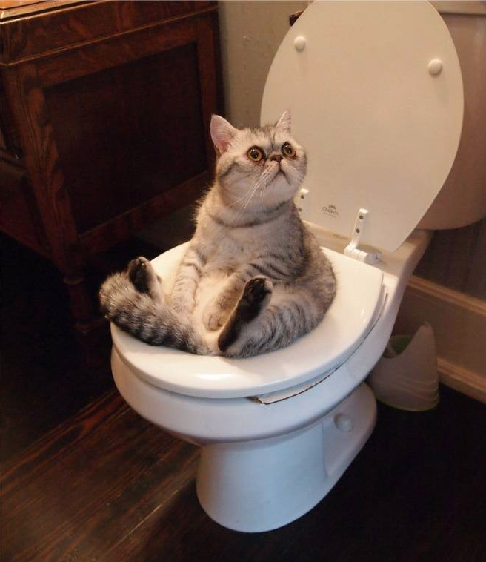

Is your feline friend urinating inappropriately?

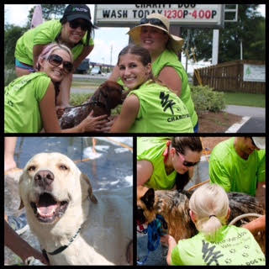

A huge thanks to those who came out to support us at our Annual Charity Dog Wash. We raised around $600 in just a few short hours with the help of our wonderful clients, and had fun doing it! Our charity account benefits those abandoned pets we have the opportunity to take in, as well as, select cases that are in need of financial assistance. We hope to see you again next summer!


Thank You!
550 W. Nine Mile Road
Pensacola, FL 32534

Upcoming Events & Holiday Hours

September 1st-31st~ ECARE Book Drive ($5 off w/donation of a book)


September 20th~ Useless’ Birthday! He’s 16!

October 1st – 31st ~ Feline Wellness Month -25% off visits & services

November 1st-30th ~ Military Month 10% off entire invoice

November 25th ~ Closing at Noon

November 26th & 27th ~ Closed for Thanksgiving Holiday

December 24th ~ Closing at Noon

December 25th ~Closed for Christmas Holiday

December 31st Closing at Noon

January 1st~ Closed for New Years Holiday

