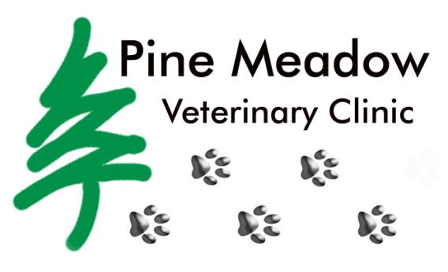

PMVC has 8 kittens about 5-6 weeks old looking for their furever homes!

Pine Meadow Veterinary Clinic, 850-477-2194

550 West Nine Mile Road, Pensacola, FL 32534

www.pinemeadowvetclinic.com   [contactpmvc@gmail.com](mailto:contactpmvc@gmail.com)

The Gulf Coast area is the ideal destination for cooling off in the waves or splashing around in the pool on a hot summer day! However, the water can be dangerous for pets if safety is not the first priority. Owners should not assume that pets can swim and pets should never be left unattended around any body of water. A pet life vest is always an option if the owner is unsure if the pet can swim or can be used as a precautionary measure. Many local outdoor and pet specialty stores carry pet life vests for many different sizes of pets. Another concern to be cautious of is the body of water. Some local bodies of water are not safe for pets to swim in as they are polluted and may contain contaminants that are harmful to pets. It is important for owners to do research prior to letting pets go for a swim. Once the owner has assured that the body of water is safe for the pet, they will need to make sure that they clean the pet afterwards and maintain dry clean ears. Pets can get ear infections from too much moisture in the ears. Some symptoms of an ear infection include: shaking the head excessively, rubbing the head on the floor or ground, scratching ears, or odor. Pine Meadow Vet Clinic offers several over the counter ear flushes that clean and dry moisture from the ears. These products can help to prevent your loved one from having a painful ear infection!



Inside This Issue

1 Water Safety Tips

2 Heartworm Prevention

3 Microchip Information

4 Vacationing with Pets

5 Calendar of Events

# Splash into safety!

Pine Meadow

Newsletter

Summer 2016

# 

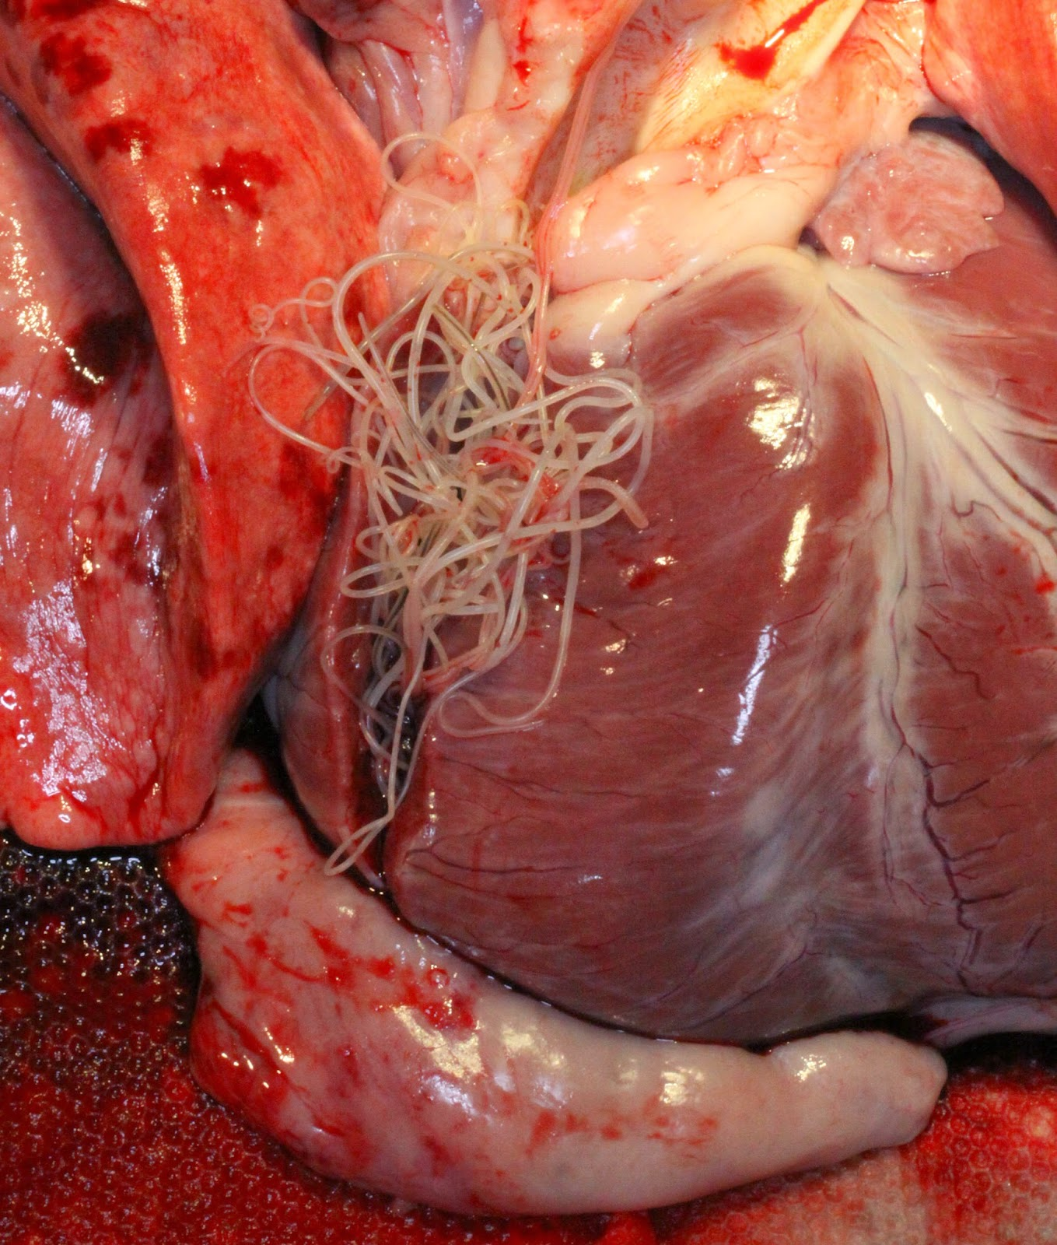

There are many products available to effectively prevent heartworm disease. Commonly used products include Heartgard Plus (a beef flavored chewable), Trifexis (a heartworm prevention and flea control combination), and Proheart (an injectable prevention administered every 6 months). These and other heartworm preventions can be purchased at PMVC. If your canine companion is not currently on heartworm prevention, please schedule a visit with one of our veterinarians.

During the visit, your dog will be tested for heartworms with a simple blood test performed in the clinic. Dogs test positive approximately 6-8 months after being bitten by an infected mosquito. If the test comes back negative for heartworm disease, it is highly recommended that the pet is started on prevention. Prevention of heartworm disease is far more effective and much less costly than treatment of an infected pet.

Approximately 300,000 dogs are diagnosed with heartworm disease each year. Heartworm disease is a condition in which the parasitic worm, *Dirofilaria immitis,* infects a pet. These worms are transferred through the bite of a mosquito as baby heartworms (also called microfilariae). Once in a canine host they mature into adult heartworms and reproduce. The worms then take over the heart, lungs, and blood vessels of the infected pet. Once infected, a dog will experience severe lung disease, heart failure, organ failure, and often times death of the infected pet.

# We Heart Our Pets!

**There’s No Place like Home**

On February 24, 2016 Lumpia went missing from her home in Pensacola, Fl. She was microchipped with a HomeAgain microchip. The owner contacted HomeAgain and they immediately sent out Lost Pet Alerts to the Pet Rescuer Community and even sent lost pet flyers to the owner to post. About two months passed and the owner was beginning to lose hope when she received a voicemail from HomeAgain that Lumpia had been found! She was found in the street, dehydrated, overheated, and covered in fleas. The person that found her took her to a local veterinary clinic where they fully examined her and even x-rayed her before returning her home.

There are many stories like this one where pets go missing and never return home. The Gulf Coast commonly experiences mild to severe hurricane seasons, during which many pets will go missing. Microchipping could help increase the number of pets returned to their homes after such events. A missing pet with a microchip can be scanned at shelters and veterinary clinics. Once scanned, all of the information needed to contact the owner of the pet will be available and the pet can then be returned to its home.

Microchipping your pet is relatively simple, a small chip is placed underneath the skin in the shoulder area, much like a vaccination. PMVC offers microchipping either alone or with an anesthetic procedure, such as a dental cleaning. If purchased with an anesthetic procedure the client will receive a $5 discount on the microchip.

**Should I Stay or Should I Go?**



Tips for Boarding a Pet:

* Make sure the pet is up to date on vaccines
* Walk the boarding facility prior to booking: look for climate controlled kennel area, time for exercise, watered frequently, and clean maintained cages
* Bring all necessary food and medications to the boarding facility

Tips for Traveling with a Pet:

* Pack a travel bag: food, treats, medications, bed, leash and collar, bowls, travel crate
* Bring vaccine records and ownership paperwork
* Carsickness signs: vomiting, drooling, trembling, hunched back - can get carsickness medication from veterinarian prior to departure
* Microchip prior to leaving and have tags on pets at all times

PMVC offers boarding facilities for clients as long as pets are up to date on vaccinations and have seen a doctor within the last year for an exam.

Planning a getaway with your best friend? Taking pets on vacations can be very rewarding both for the pet and the owner in that the bond grows stronger between them. The pet can meet new friends and they can also experience new environments away from their home. However, some pets are not good travelers and would benefit better from being boarded for the weekend. Once the owner has decided to go on vacation they have to make the decision of how the pet will do with traveling based on how they act during car rides and if they do well in boarding facilities. When the decision has been made the owner will want to call their hotel to make sure that it is pet friendly or call their veterinarian to schedule boarding.



PMVC and CARE of Santa Rosa County Rescue will be teaming up for the annual dog wash and adoption event. The event is being held at Pine Meadow Veterinary Clinic and all donations will fund CARE of Santa Rosa County Rescue and Pine Meadow’s Compassion Fund.

**Pine Meadow’s 5th Annual Dog Wash and Adoption Event is June 11th, 2016**





550 W. Nine Mile Road

Pensacola, FL 32534

**Upcoming Events & Hours**

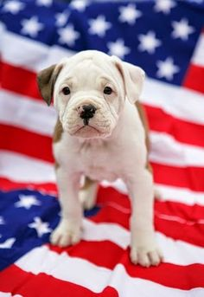**Closed Memorial Day, July 4th, Labor Day, Thanksgiving and Black Friday,Christmas, New Year’s Day**

**Closed half day Wednesday before Thanksgiving, Christmas Eve, and New Year’s Eve**

**September- Back to school drive. Donate a book to ECARE and receive $5 off your visit**

**October 22, 2016- PMVC First Annual 5K Run**

**October- Sponser mammograms. For every spay performed in October, 10% of the procedure will be donated to Baptist Free Mammogram Clinic**

**November- National Dog Show. Pick best in show and win a free bath and grooming kit.**

**December- ARC Gateway Wreath Gala**